Experiment No. | 10
Aim | Approximation algorithms (The vertex-cover problem)
Name | Sakshi D Lonare
UID No. | 2021300069
Class & Division | Comps SE A

Algorithm:-
SOLVE(){
bool visited[total_vertices] <- {false, false, ......., false}
for u <- 0 to total_vertices:
if visited[u] is false:
for v <- vertices[u]:
if visited[v] is false:
visited[v] = visited[u] <- false
break;

for i <- 0 to total_vertices:
if visited[i] is true:
print i
}

Program:-
#include <stdio.h>
#include <stdlib.h>
#include <stdbool.h>

typedef struct {
int v;
int e;
int adj[100][100];
} Graph;

typedef struct {
int size;
int set[100];
} VertexCover;

void init_graph(Graph *G, int v, int e) {
G->v = v;
G->e = e;
for (int i = 0; i < v; i++) {
for (int j = 0; j < v; j++) {
G->adj[i][j] = 0;
}
}
}

void add_edge(Graph *G, int u, int v) {
G->adj[u][v] = 1;
G->adj[v][u] = 1;
}

VertexCover vertex_cover_2approx(Graph *G) {
VertexCover cover;
bool visited[100] = { false };

for (int i = 0; i < G->v; i++) {
if (!visited[i]) {
for (int j = 0; j < G->v; j++) {
if (G->adj[i][j] && !visited[j]) {
visited[i] = true;
visited[j] = true;
cover.set[cover.size++] = i;
cover.set[cover.size++] = j;
break;
}
}
}
}

return cover;
}

int main() {
Graph G;
int v, e;

printf("Enter the number of vertices: ");
scanf("%d", &v);

printf("Enter the number of edges: ");
scanf("%d", &e);

init_graph(&G, v, e);

printf("Enter the edges (u v):\n");
for (int i = 0; i < e; i++) {
int u, v;
scanf("%d %d", &u, &v);
add_edge(&G, u, v);
}

VertexCover cover = vertex_cover_2approx(&G);

printf("Vertex cover of size %d: ", cover.size);
for (int i = 0; i < cover.size; i++) {
printf("%d ", cover.set[i]);
}
printf("\n");

printf("Edges removed:\n");
for (int i = 0; i < cover.size; i++) {
for (int j = i + 1; j < cover.size; j++) {
if (G.adj[cover.set[i]][cover.set[j]] == 1) {
printf("(%d, %d)\n", cover.set[i], cover.set[j]);
}
}
}

return 0;
}

Output:-
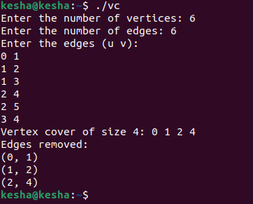

Conclusion:- I learnt how to solve the vertex cover problem using approximation algorithms. The 2-approximation algorithm, produces a vertex cover that is at most twice the size of the optimal vertex cover.

